**Home:**

In our project, we are detecting the fake reviews from the review entered by the user.



**Fig1**: Home

Home Page of our project

**About:** 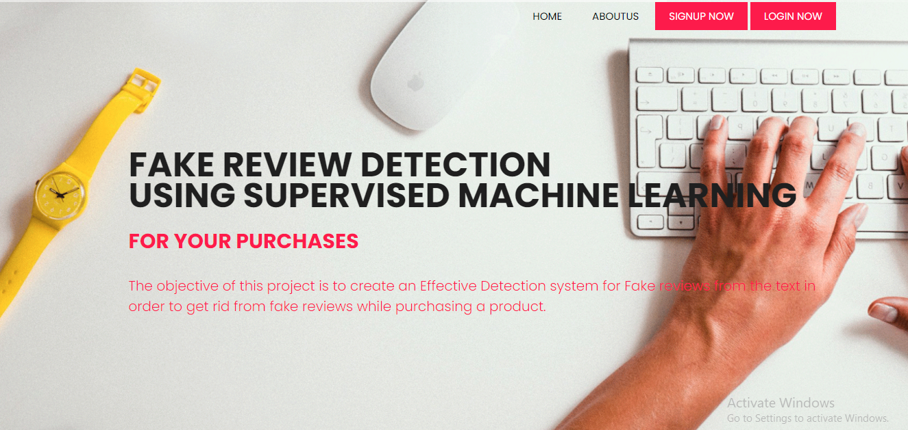

**Fig2**: About

Here the application describes what main objective of this project is.

**Registration**:

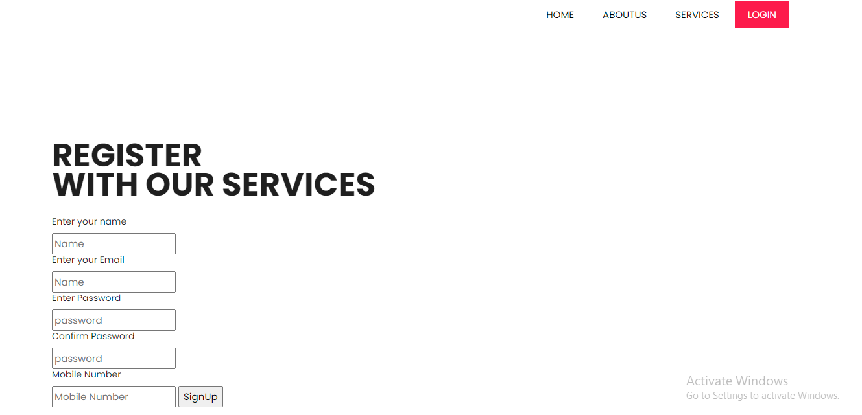

**Fig3**: Registration

Registration page in which user need to register to start.

**Login:**

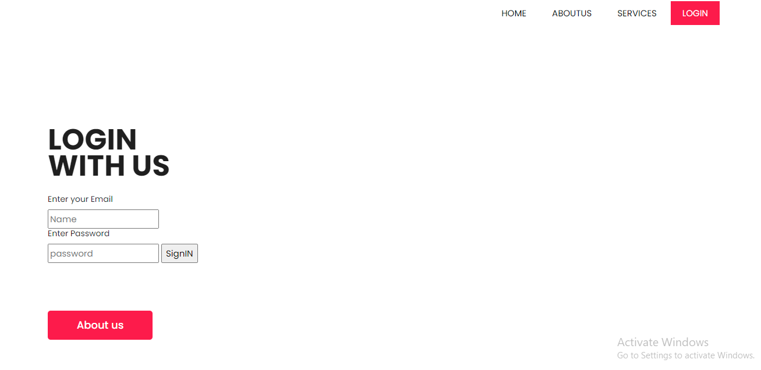

**Fig4**: Login Page

Login page, user need to enter valid credentials in order to enter.

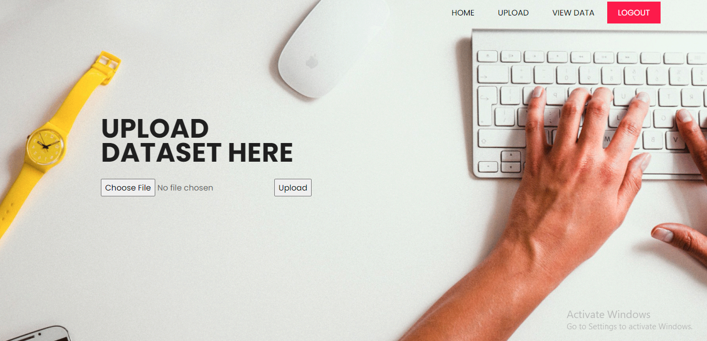

**Fig5**: Upload Page

Upload Page in order to upload the dataset.

**View Data:**

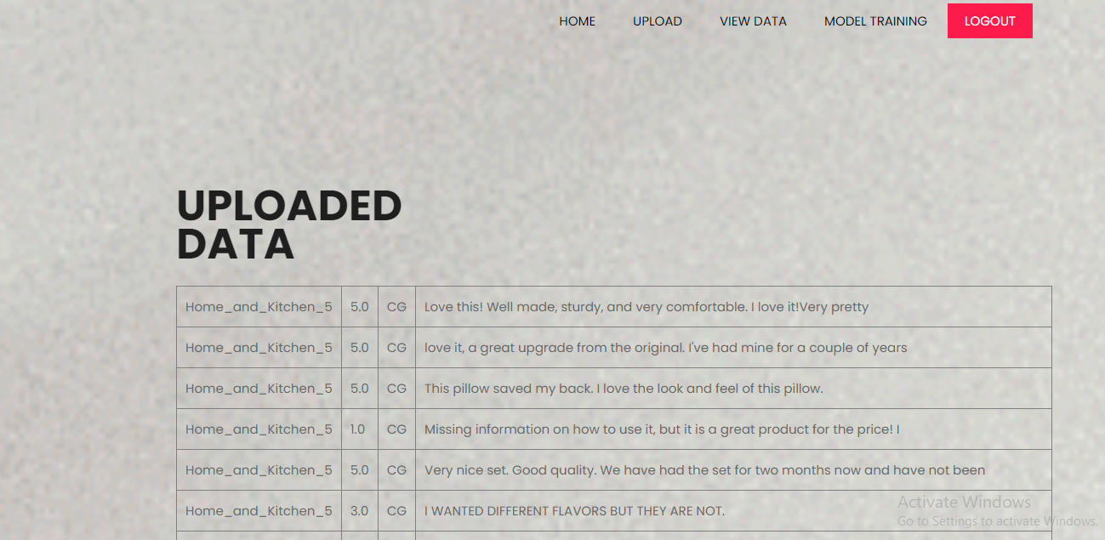

**Fig6**: View Dataset Page

User views the data which he was uploaded to the system.

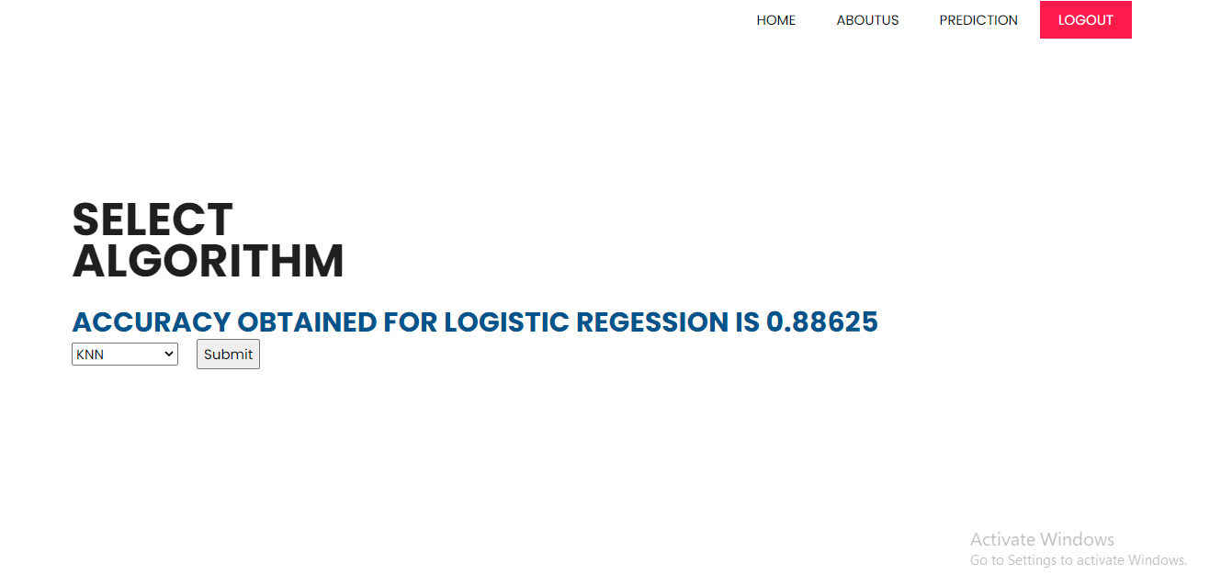

**Fig7**: Model Training

Here training of your model takes place and display the model’s accuracy

**Prediction:**

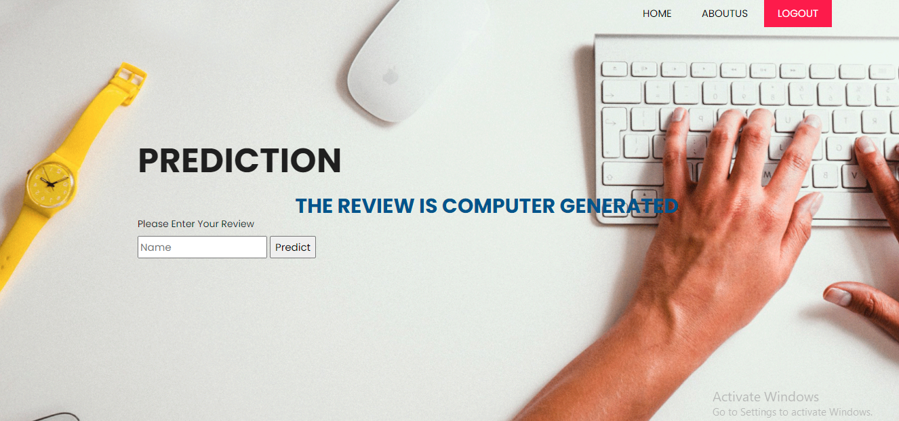

**Fig6**: Prediction Page

User need to enter the required fields in order to get the response from the data whether the review is computer generated or original.